# SQL QUERIES

# A.KPI’S

# 1. TOTAL REVENUE

SELECT

SUM(total_price) AS Total_Revenue

FROM

`pizasales.PizaSales.Sales`;

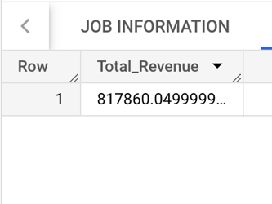

# 2. AVERAGE ORDER VALUE

SELECT

SUM(total_price) /

COUNT(DISTINCT order_id ) AS Avg_order_value

FROM

`pizasales.PizaSales.Sales`;

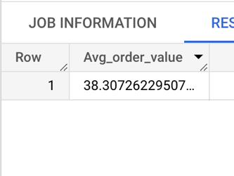

# 3. TOTAL PIZA SOLD

SELECT

SUM(quantity) AS Total_piza_sold

FROM

`pizasales.PizaSales.Sales`;

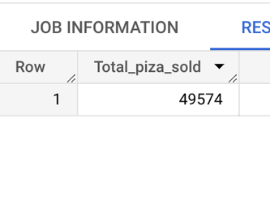

# 4. TOTAL ORDER PLACED

SELECT

COUNT(DISTINCT order_id ) AS total_order_placed

FROM

`pizasales.PizaSales.Sales`;

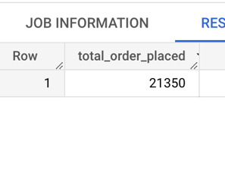

# 5. AVERAGE PIZA ORDER

SELECT

ROUND(SUM(quantity) /

COUNT(DISTINCT order_id), 2) AS Avg_pizza_order

FROM

`pizasales.PizaSales.Sales`;

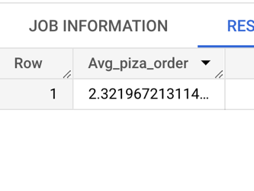

# B.CHARTS

# 1. DAILY TREND FOR TOTAL ORDERS

SELECT

FORMAT_DATETIME("%A", order_date) AS order_day,

COUNT(DISTINCT order_id) AS Total_orders

FROM

`pizasales.PizaSales.Sales`

GROUP BY

order_day;

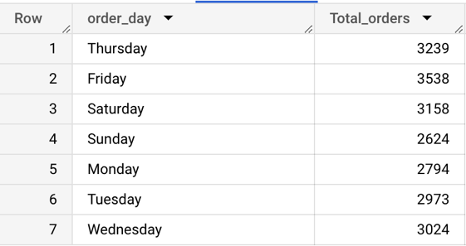

# 2.MONTHLY TREND FOR TOTAL ORDERS

SELECT

FORMAT_DATETIME("%B", order_date) AS order_month,

COUNT(DISTINCT order_id) AS Total_orders

FROM

`pizasales.PizaSales.Sales`

GROUP BY

order_month

ORDER BY

Total_orders DESC;

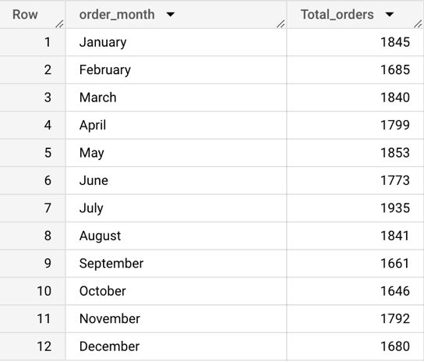

# 3.PERCENTAGE OF SALES BY PIZA CATEGORY

SELECT

pizza_category AS Category,

SUM(total_price) * 100 /

(SELECT SUM(total_price) FROM `pizasales.PizaSales.Sales`) AS Percentage

FROM

`pizasales.PizaSales.Sales`

GROUP BY

Category;

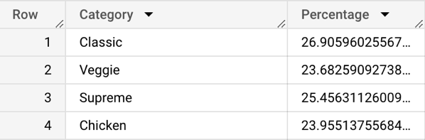

# 4.PERCENTAGE OF SALES BY PIZA SIZE

SELECT

pizza_size ,

SUM(total_price) * 100 /

(SELECT SUM(total_price) FROM `pizasales.PizaSales.Sales`) AS Percentage

FROM

`pizasales.PizaSales.Sales`

GROUP BY

pizza_size;

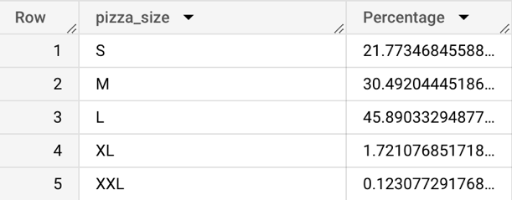

# 5.TOTAL PIZA SOLD BY PIZA CATEGORY

SELECT

pizza_category AS Piza_category,

SUM(quantity)

FROM

`pizasales.PizaSales.Sales`

GROUP BY

Piza_category;

# 

# 6.TOP 5 BEST SELLERS BY TOTAL REVENUE

SELECT

pizza_name ,

ROUND(SUM(total_price),2) AS Total_revenue

FROM

`pizasales.PizaSales.Sales`

GROUP BY

pizza_name

ORDER BY

Total_revenue DESC

LIMIT

5;

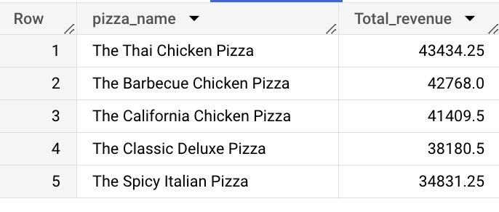

**7.BOTTM 5 WORST SELLERS BY TOTAL REVENUE**

SELECT

pizza_name ,

ROUND(SUM(total_price),2) AS Total_revenue

FROM

`pizasales.PizaSales.Sales`

GROUP BY

pizza_name

ORDER BY

revenue ASC

LIMIT

5;

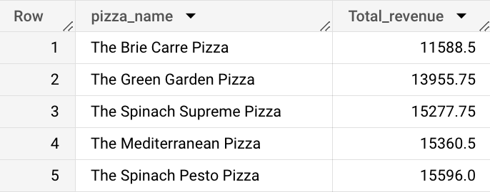

**8.TOP 5 BEST SELLERS BY TOTAL QUANTITY**

SELECT

pizza_name ,

SUM(quantity) AS Total_quantity

FROM

`pizasales.PizaSales.Sales`

GROUP BY

pizza_name

ORDER BY

Total_quantity DESC

LIMIT

5;

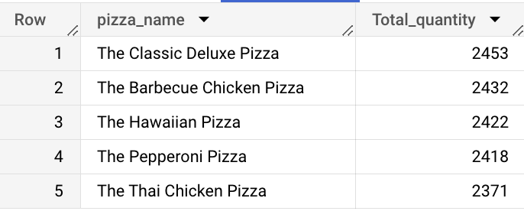

**9.BOTTM 5 WORST SELLERS BY TOTAL QUANTITY**

SELECT

pizza_name ,

SUM(quantity) AS Total_quantity

FROM

`pizasales.PizaSales.Sales`

GROUP BY

pizza_name

ORDER BY

Total_quantity ASC

LIMIT

5;

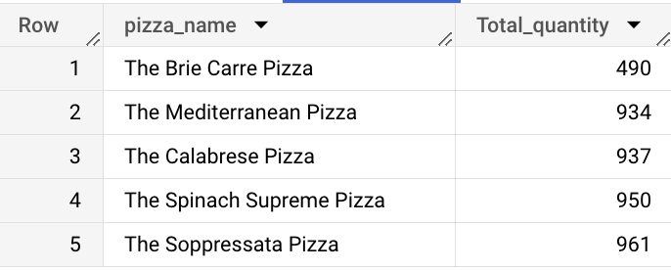

**10.TOP 5 BEST SELLERS BY ORDERS**

SELECT

pizza_name ,

COUNT(DISTINCT order_id) AS Total_orders

FROM

`pizasales.PizaSales.Sales`

GROUP BY

pizza_name

ORDER BY

Total_orders DESC

LIMIT

5;

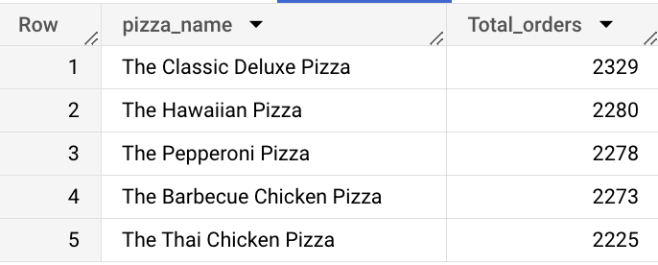

**11.BOTTM 5 WORST SELLERS BY ORDERS**

SELECT

pizza_name ,

COUNT(DISTINCT order_id) AS Total_orders

FROM

`pizasales.PizaSales.Sales`

GROUP BY

pizza_name

ORDER BY

Total_orders ASC

LIMIT

5;

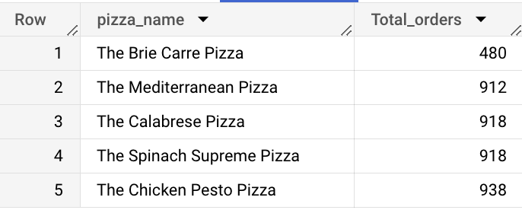

**12.HOURLY TREND FOR TOTAL PIZAS SOLD**

SELECT

EXTRACT(HOUR FROM order_time) AS Order_hour,

SUM(quantity) AS Total_pizas_sold

FROM

`pizasales.PizaSales.Sales`

GROUP BY

Order_hour

ORDER BY

Order_hour;

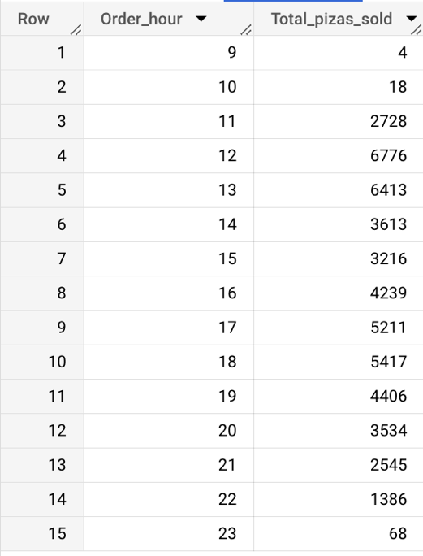

**13.WEEKLY TREND FOR TOTAL ORDERS**

SELECT

EXTRACT(WEEK FROM order_date) AS Week_number,

EXTRACT(YEAR FROM order_date) AS Year,

COUNT(DISTINCT order_id) AS Total_orders

FROM

`pizasales.PizaSales.Sales`

GROUP BY

Week_number,Year

ORDER BY

Week_number,Year

